Chuanjie ZANG

699382953

Step 1 : Use the circle and line tools to draw 2 images, the one on the left is the 'big head' and the one on the right is the 'small head'

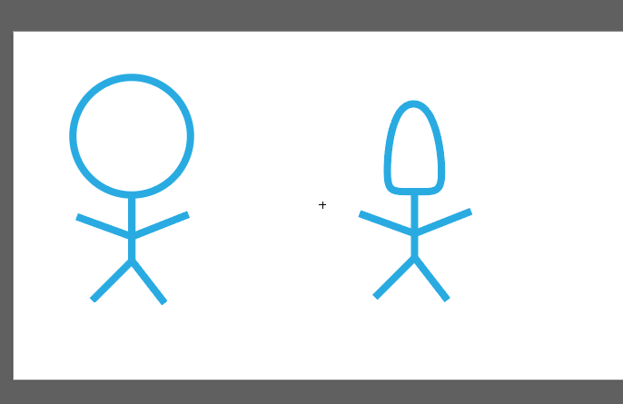

Step 2 : window - symbols - new symbol, add two images as symbols

Step 3 : window - artboards - new artboard

Step 4 : Use three different methods to add two newly created symbols to this panel.

Method 1: Drag and drop directly from the Symbol Panel onto the drawing board.

Method 2: Use the "Symbol Sprayer" tool to spray the symbols on the board.

Method 3: symbols panel - place symbol instance

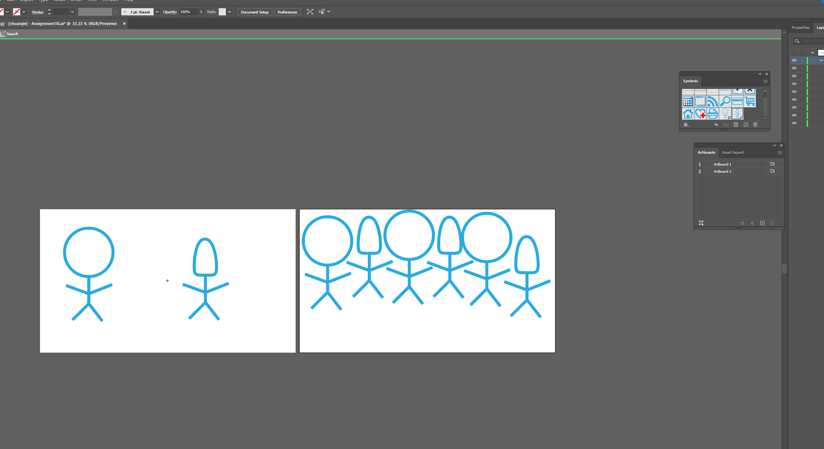

Step 5 : Edit the first symbol 'Big Head' and replace the head of the big head with a square one, all the big head symbols on the drawing board will become square heads.

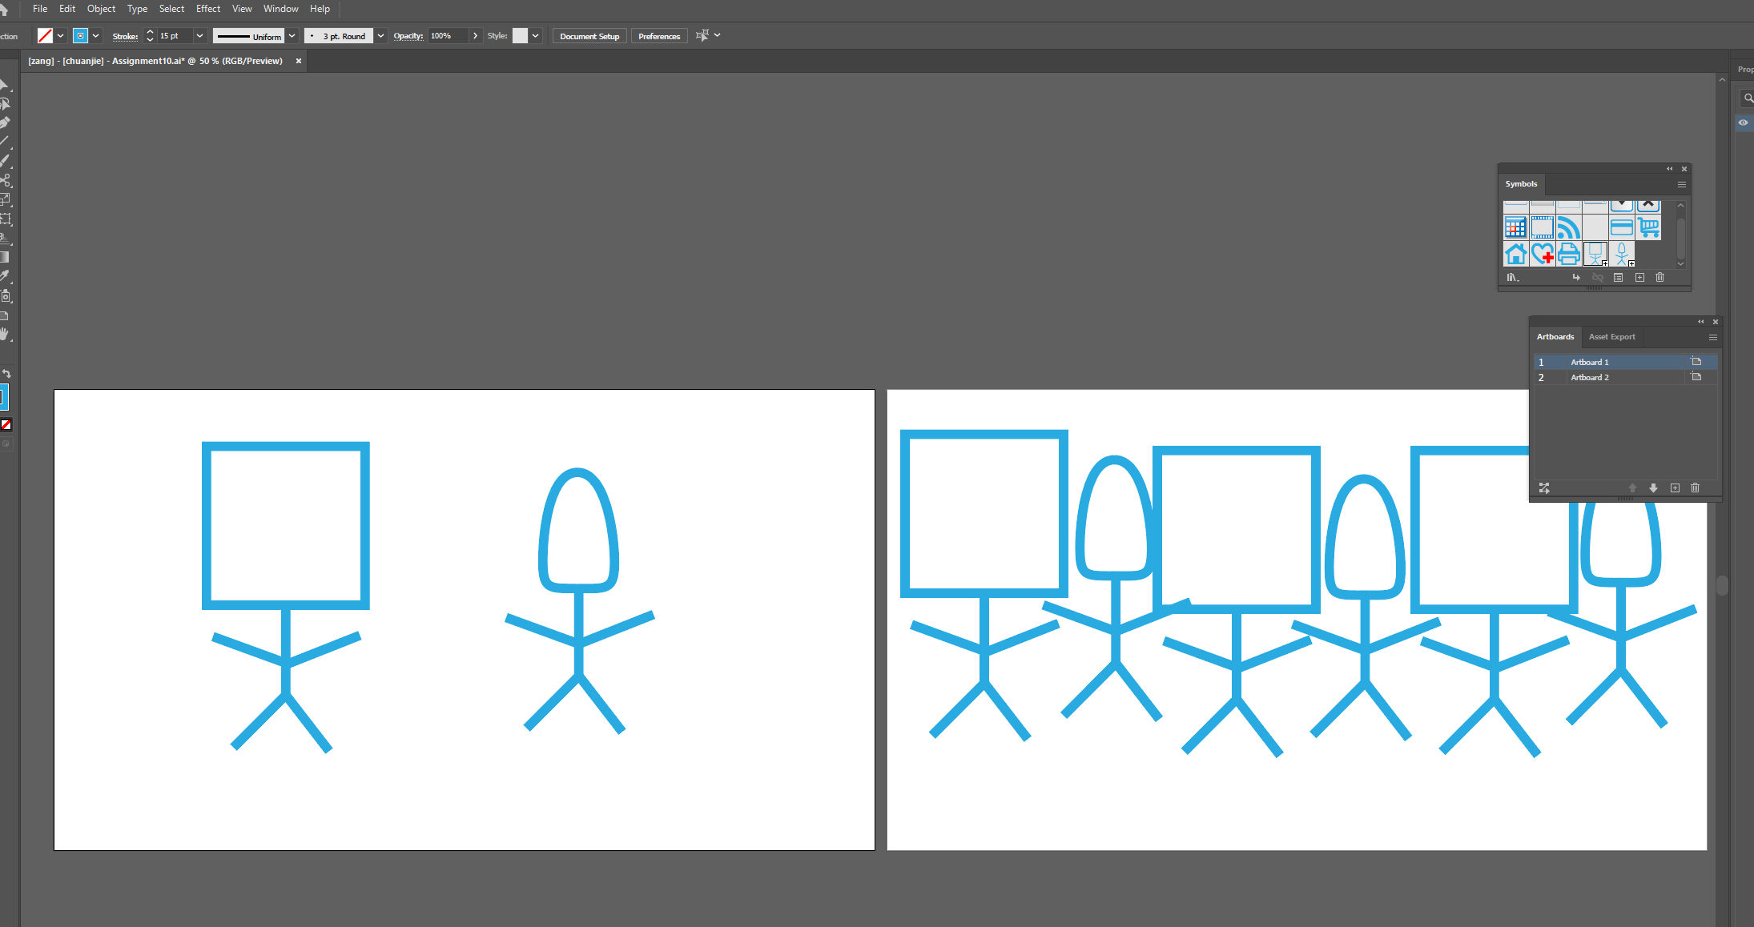

Step 6 : Select the 'small head' in the first panel, click on 'break link to symbol' in the symbol panel, then replace the head of the small head with a star. Only the cast of this one little header is replaced.

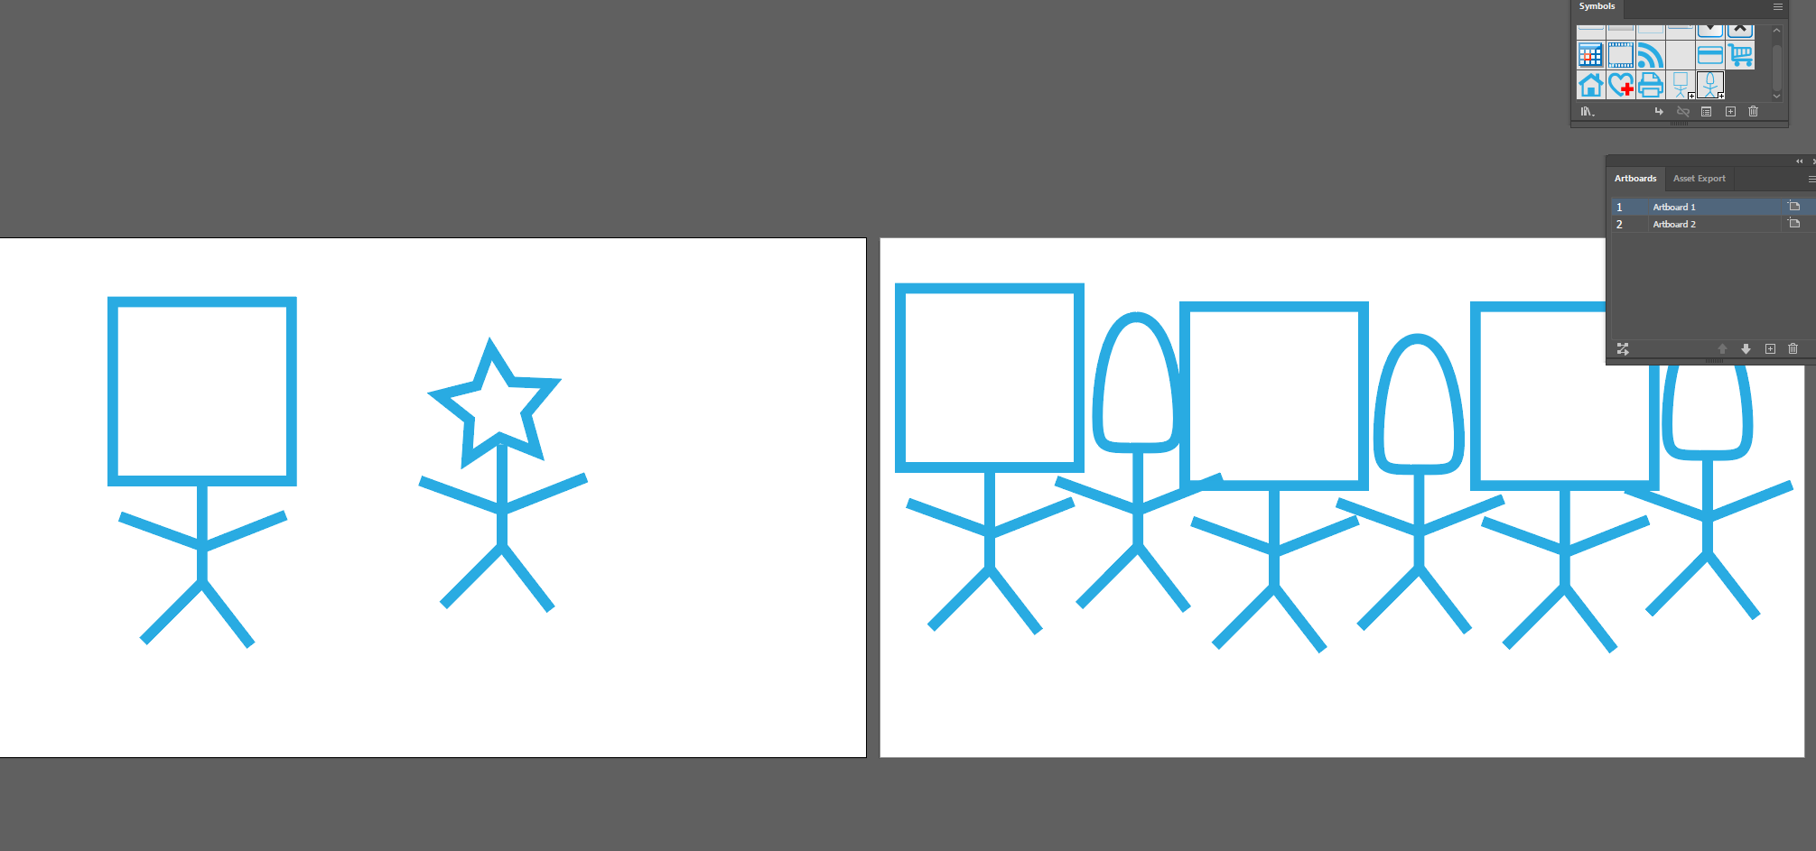

Step 7 : libraries - your libraries, drag 'big head' into the panel

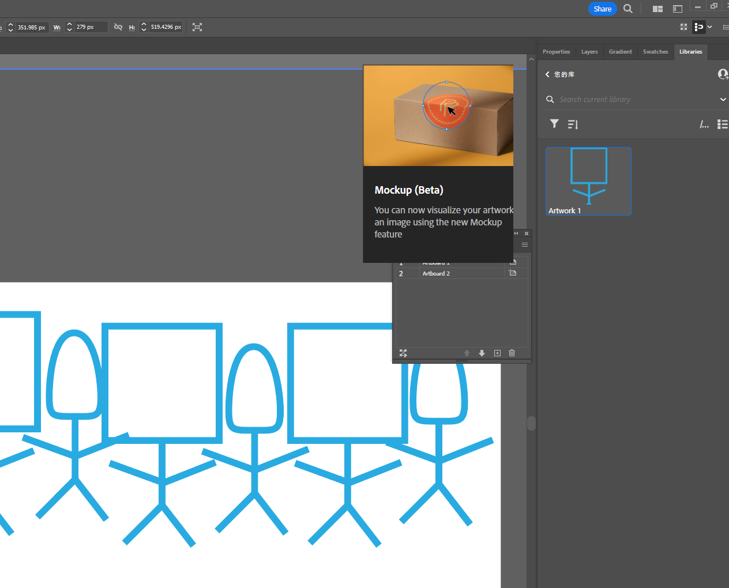

Step 8 : window - artboard - creat new board - rename to ‘Using Library Assets’，Drag the 'big head' from libraries to this panel

